Programming Fundamentals Lab

Lab Assignment 04

Course Code: CL1002

Syed Muhammad Shuja Ur Rahman

Roll No. 22K-4456

Ms. Ayesha Ali

**Task 01:** Ahmed answered 30% of the questions correctly. The test contained a total of 80 questions. Write a program to tell how many questions did Ahmed answer correctly.

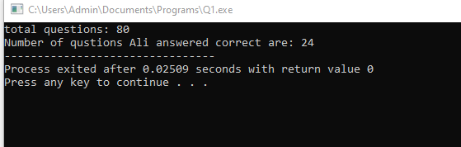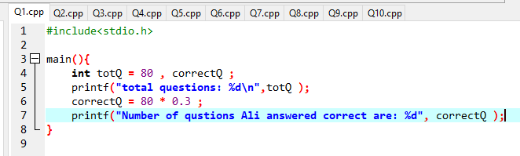

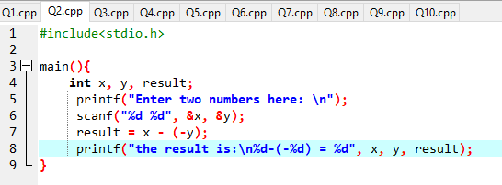**Task** **02:** Write a program to find the sum of two integers without using ‘+’ operator.

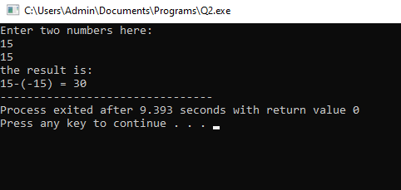

**Task 03:** Take relevant inputs from the user according to formula and calculate the area of: (1). Circle (2) Square (3). Rectangle; Formulas:

Area of Circle = pi * radius2

Area of Square = length2

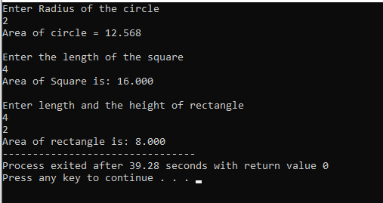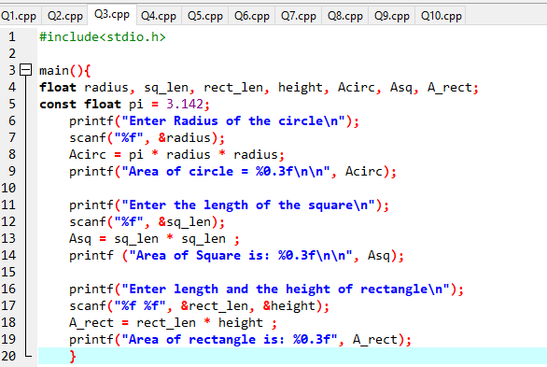 Area of Rectangle = length * height

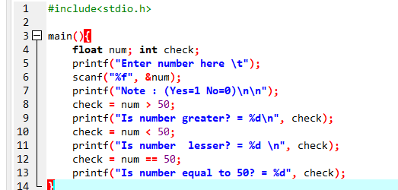**Task 04** Write a program to take a number as user input and the check the following conditions (1). Number is greater than 50. (2). Number is less than 50, (3). Number is equal to fifty.

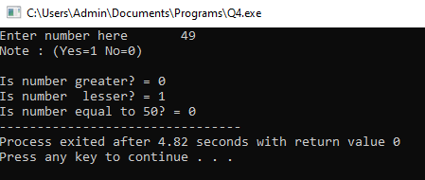

**Task 05** A students’ report card needs to be developed. Write a program that takes marks of 5 subjects each of 100 marks. The subjects are: 1. Math 2. Urdu 3. English 4. Islamiyah 5. Pakistan Studies Calculate the percentage and total marks obtained.

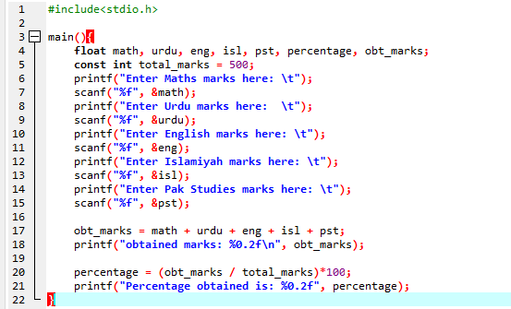

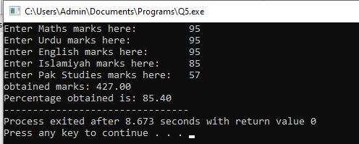

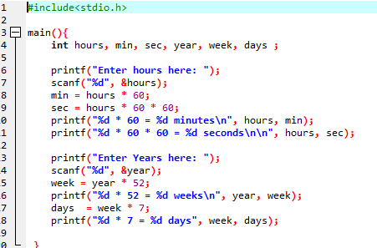**Task 06** Write a C program that performs the following tasks: (1). Take hours from user, convert it into minutes and seconds. (2). Take years from user, convert it into weeks and days.

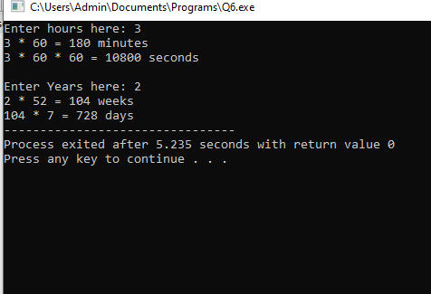

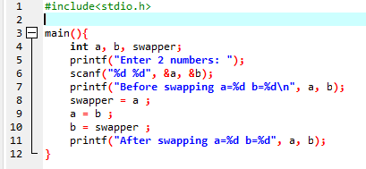**Task 07** Write a program to swap 2 numbers using a third variable. For example: A = 2, B=4 After swap A=4, B=2

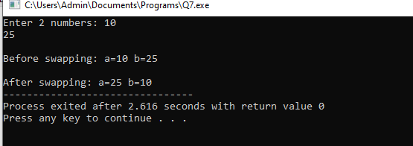

**Task 08** Create a two-input truth table of AND gate, OR gate and Not gate using logical operators

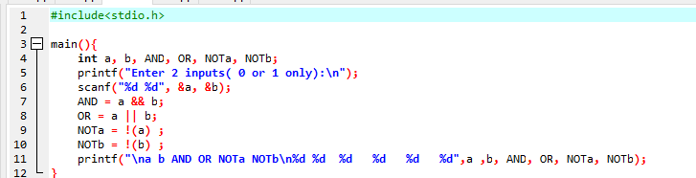

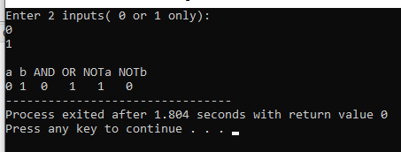

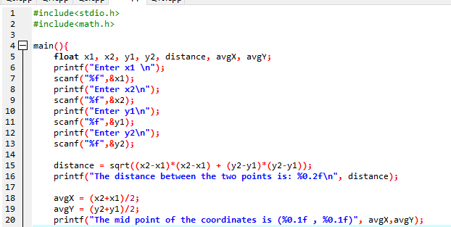**Task 09:** Write a C program to Find out distance, coordinates of midpoint using distance formula, derived from Pythagorean Theorem and value of X by Quadratic formula, as follows***: Midpoint= ((x2+x1/2), (y2+y1/2))***

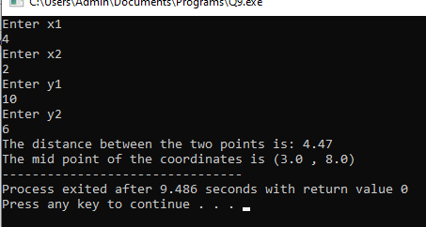

**Task 10:**

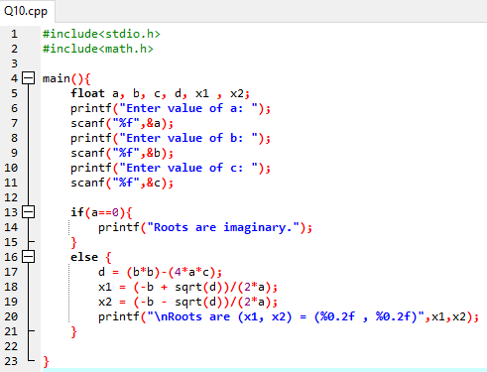Write a C program to Find the Roots of a Quadratic Equation. Take user input values of b, a, c:

***x = (−b±√b2−4ac)/2a*** Given (a≠0).

